**PORTFOLIO OF NADIA AFRIN NOOR**

**Validation**

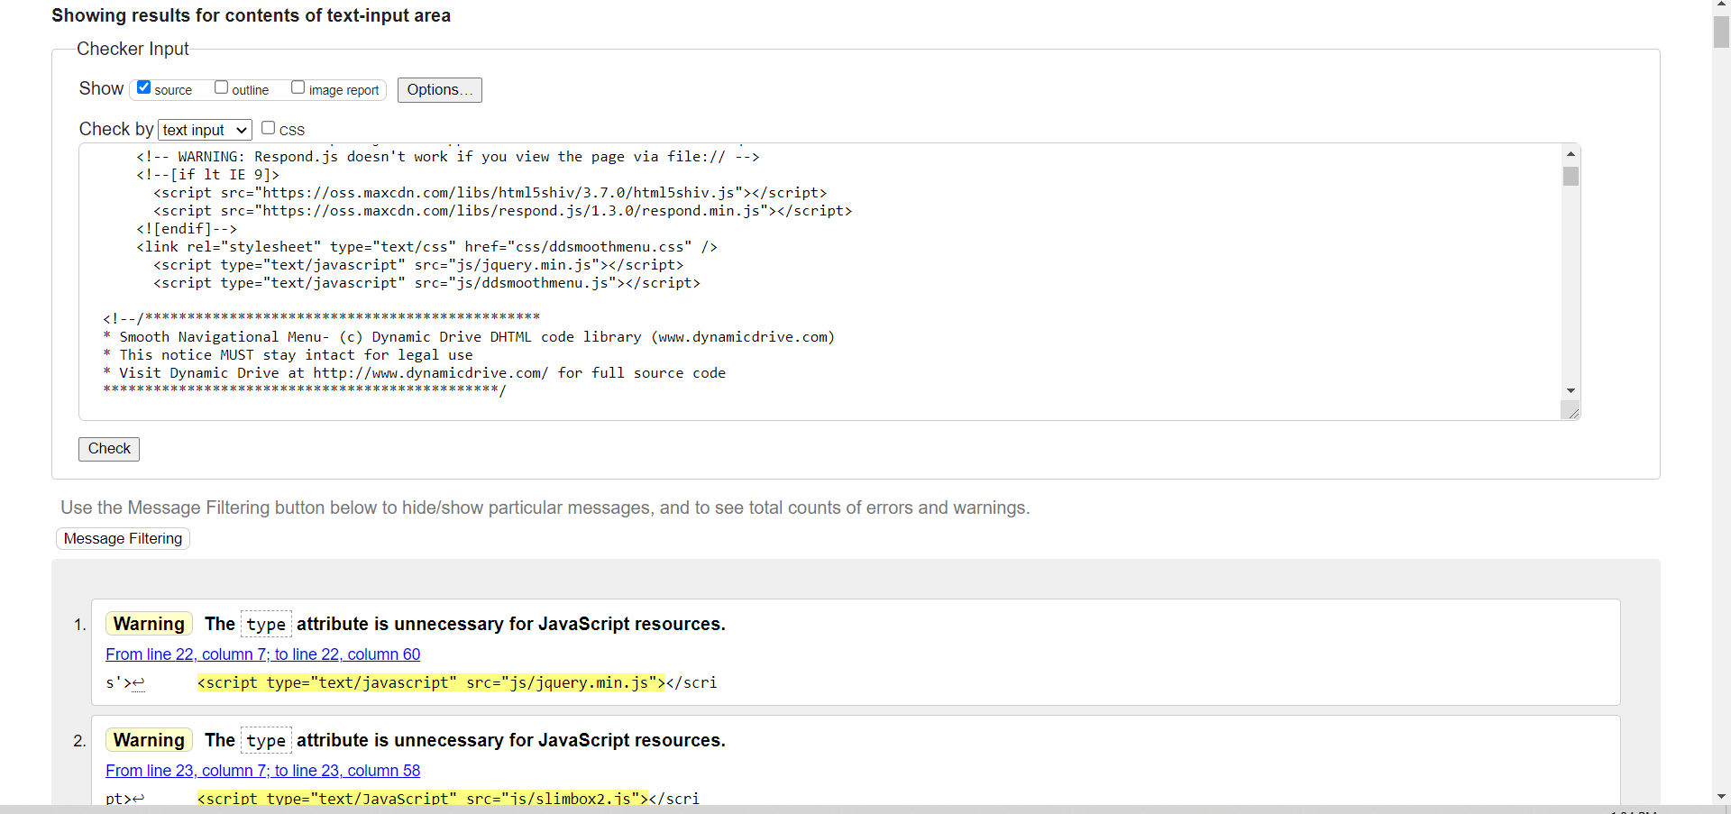The site is w3 validator compliant. It has few warnings but no errors.

**Responsiveness**

The page is responsive and it has three views: Large screen view, medium screen view (tab view) and mobile view

1. 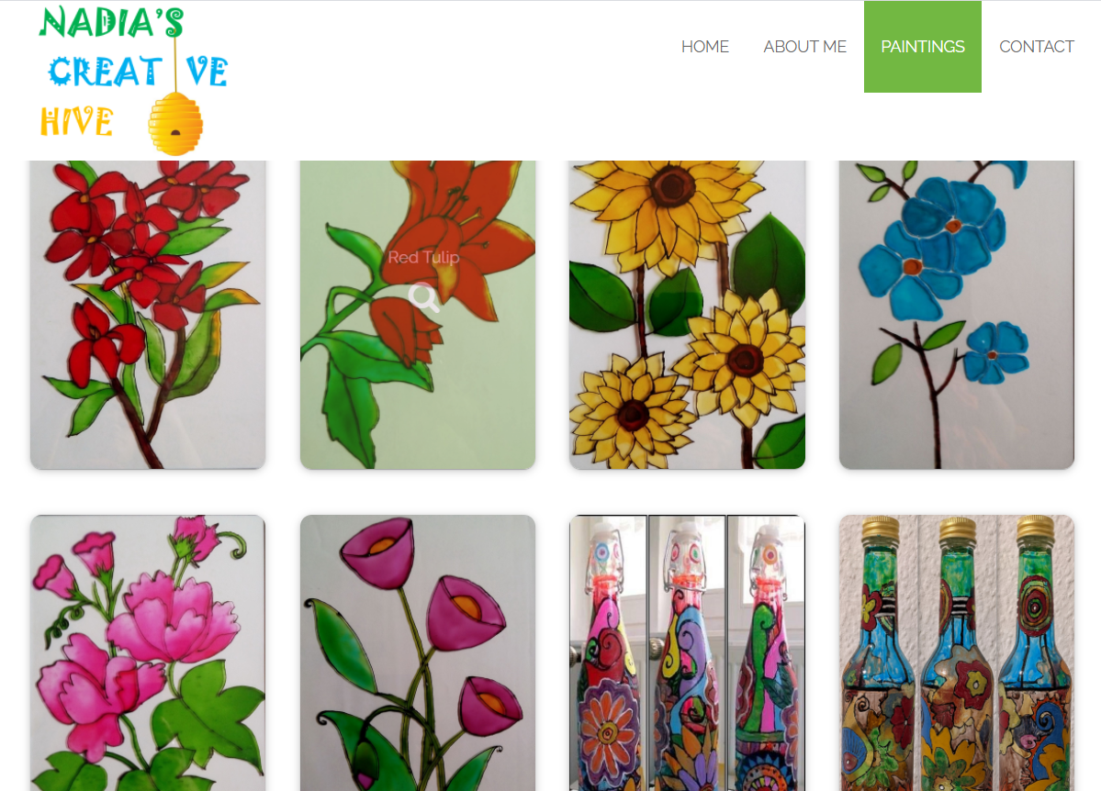Large screen view:
2. Medium screen view (tab view):

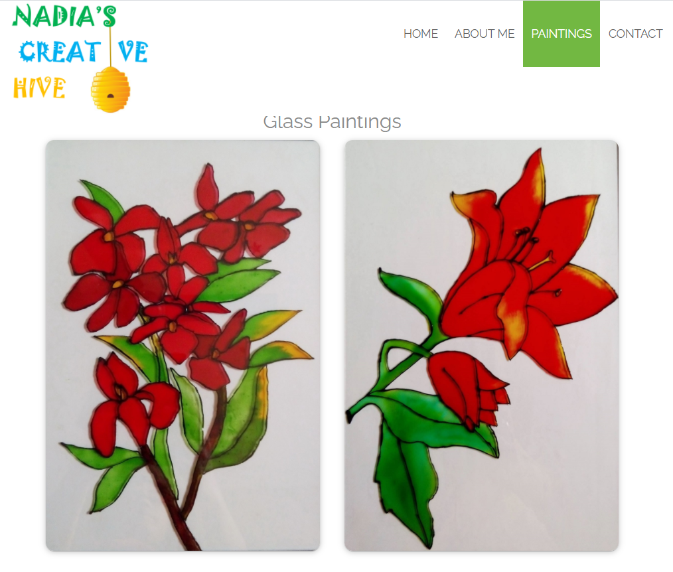

1. 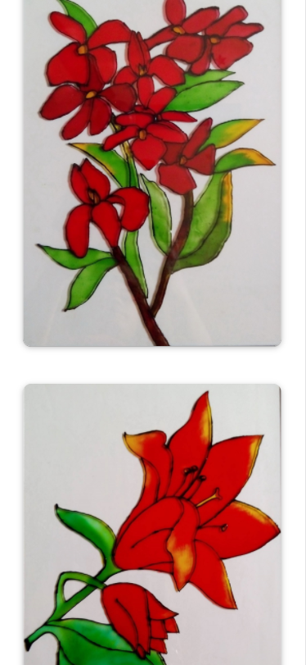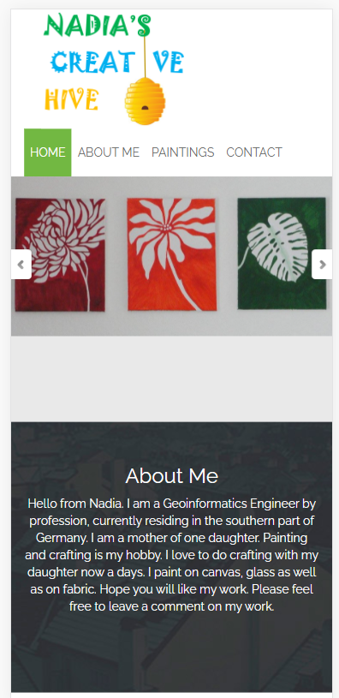Mobile view: two screenshots:

**Some CSS codes:**

* I have added shadow and border radius to style the images.

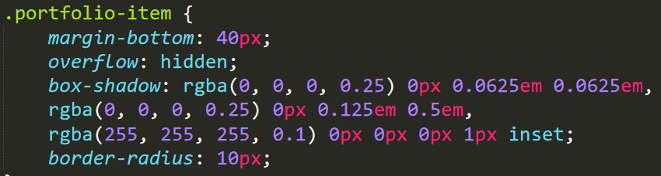

* Hover is added in the portfolio thumb class and background color is changed from solid color to transparent.

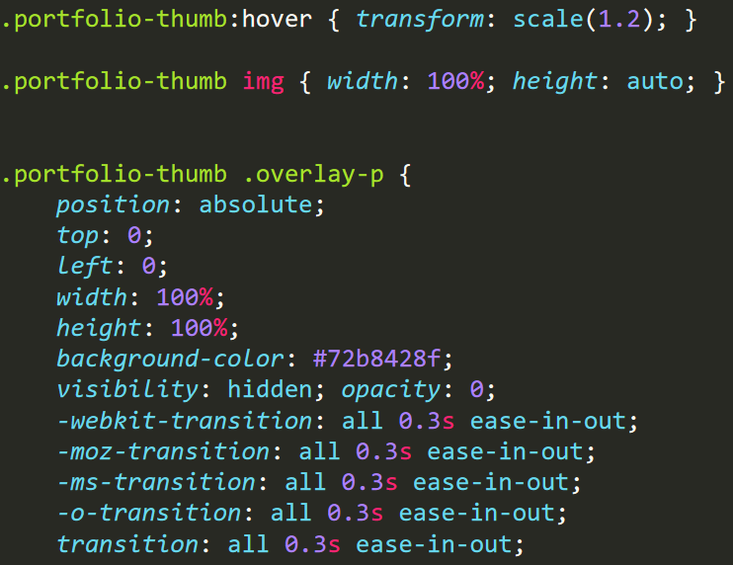

* Center-contact_us new css class is used in contact us <div> to align it in center for screen size > 768px. ‘templatemo_reasonbg’ existing css class is adopted for screen size > 768 px to have 15% margin on left and right side. The result is shown in a later section where I described the changes in website.

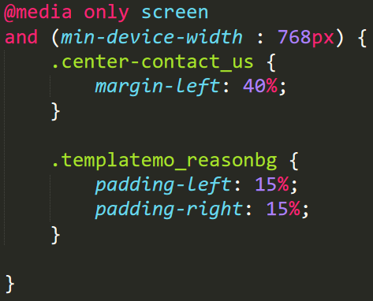

* I have added twenty-four images of my paintings under two sub headings. One is Glass paintings and the other is Acrylic paintings. Each of these sections contain twelve images. Among them, eight are directly visible and the rest four are hidden. When we click on view more, the hidden four images will be displayed. To do this, ‘showHideGlassImage()’ and ‘showHideAcrylicImage()’ Javascript functions are added to show/hide the Glass images and Acrylic images respectively. This functions are called in the click event of "View More" <anchor> button.

When all images are shown, ‘view more’ is replaced by ‘view less’ button. When we click on ‘view less’, only eight images will be displayed as before.

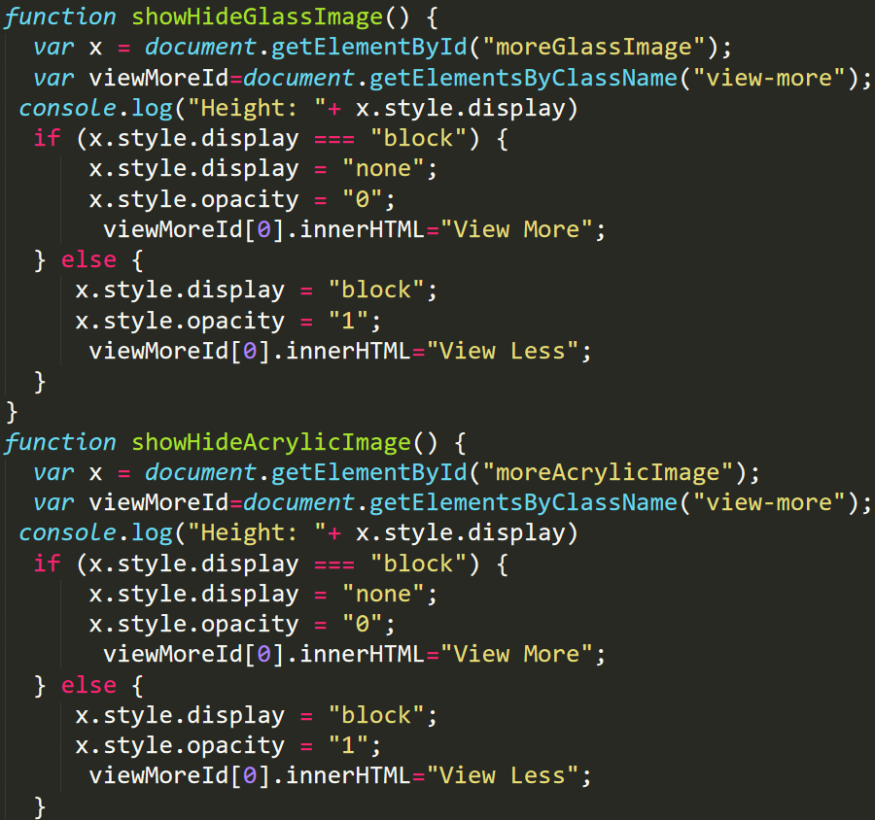

‘moreAcrylicImage’ and ‘moreGlassImage’ new css classes are added to set the initial visibility state of Acrylic images and Glass images respectively.

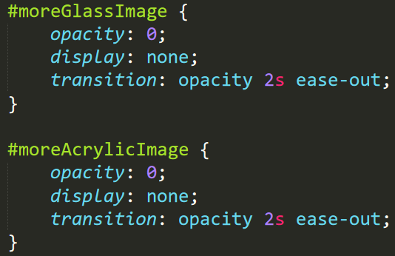

* Several fonts are used to style the file.

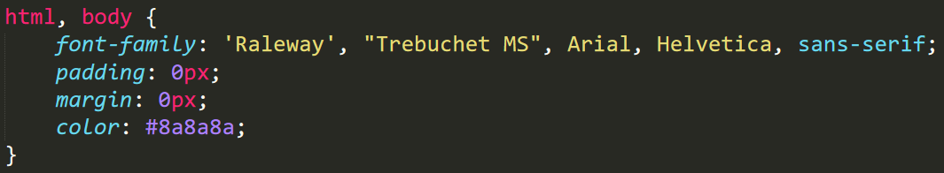

* Different colors are used throughout the site for styling purpose. Here are some examples:

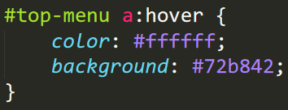

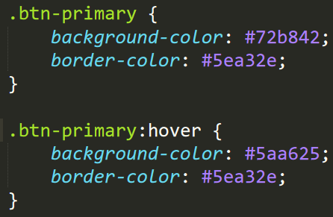

* Browser prefixes are used for perfect display of the site in different browsers.

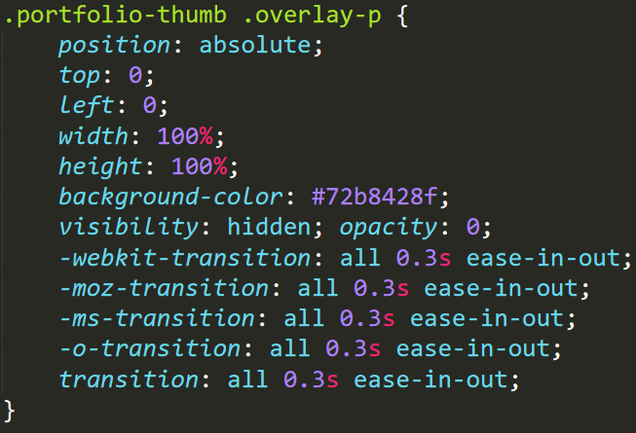

**Enhancements:**

1. I have added **JavaScript function** to view more images or less images as mentioned above.
2. **Google map** of my location (Stuttgart, Germany) is included in my site. Instead of using the full code I just used a fluid wrapper class and included only the link inside iframe.

Fluid wrapper iframe is styled in the CSS file.

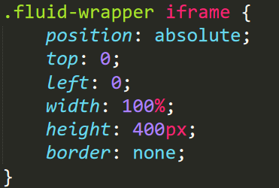

Output

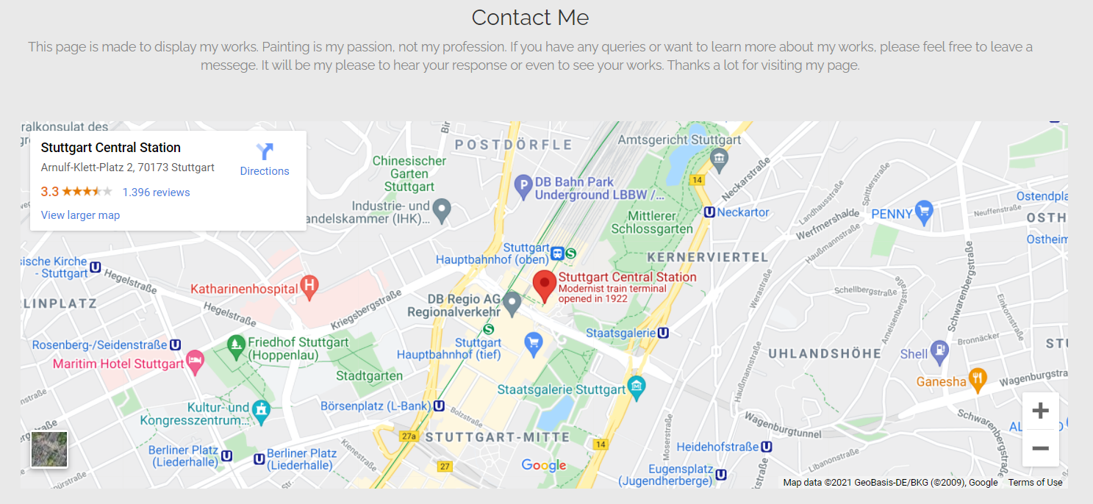

1. 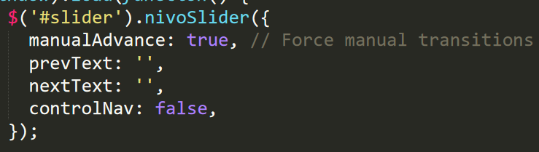I have a **carousel** in my site in the header section. It is done using nivoSlider. I used this code: manualAdvance: true, to turn off auto play. Now the carousel will only work with a click on the arrow.

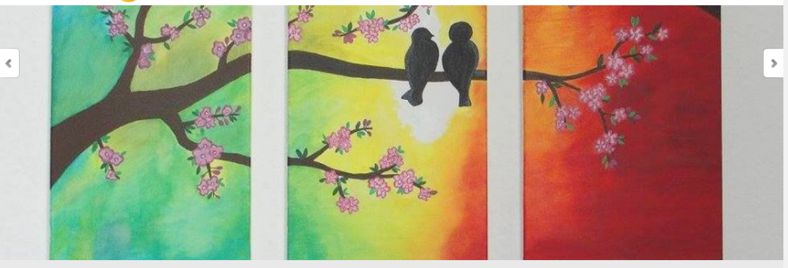Result:

1. I used a **sticky footer** showing copy write information and links of my facebook page and linkedin account.



1. I have medium screen or tab view as **a third viewport** apart from large screen view and mobile view. The three different views are shown before under responsiveness section.

**Description of Portfolio (designed from a template)**

Template used: templatemo_396_smoothy

This page is designed to display some of my paintings.

I have made some changes to meet my preferences. Here are the changes:

* The logo and some menu names are changed.
* One menu (Blog) is removed.
* Padding and margin is added in various places for styling purpose.

**Home**

* Slider images are replaced by my own work.
* Autoplay operation was replaced by manual clicking in the carousel/slider.

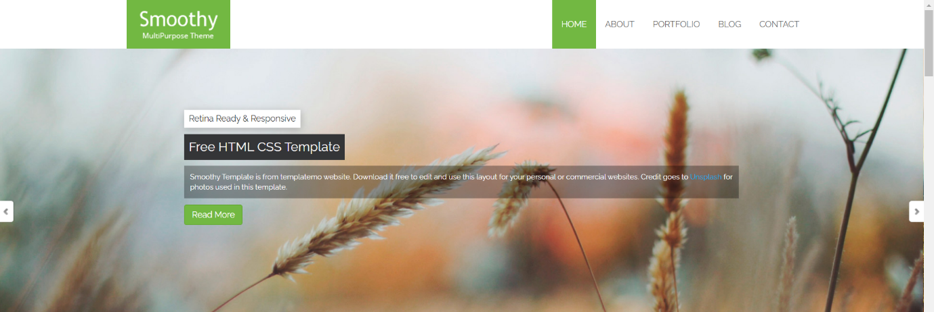

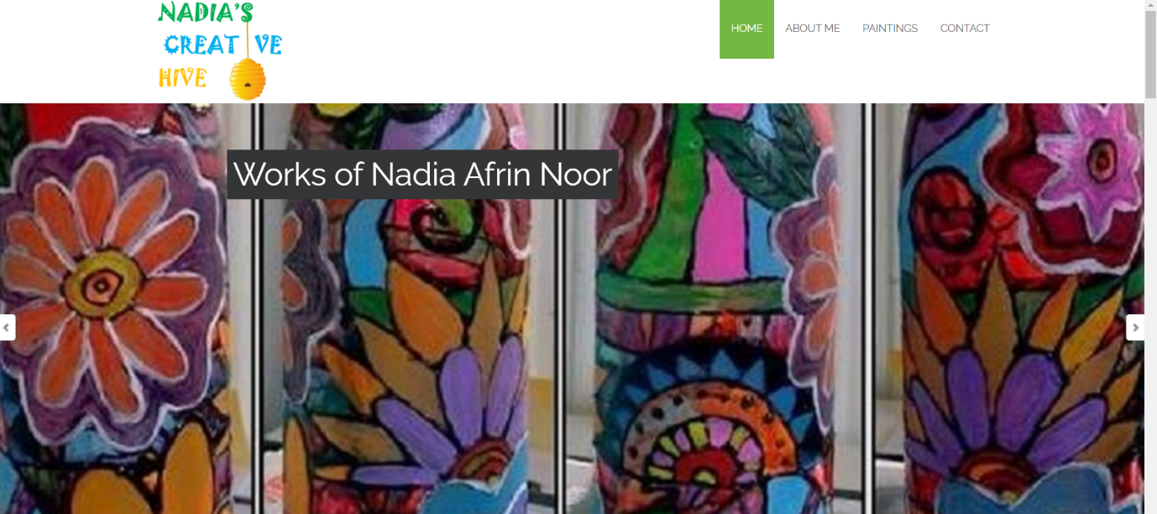

**About Me**

In this part, everything is removed. I just added some text. Images below shows the changes.

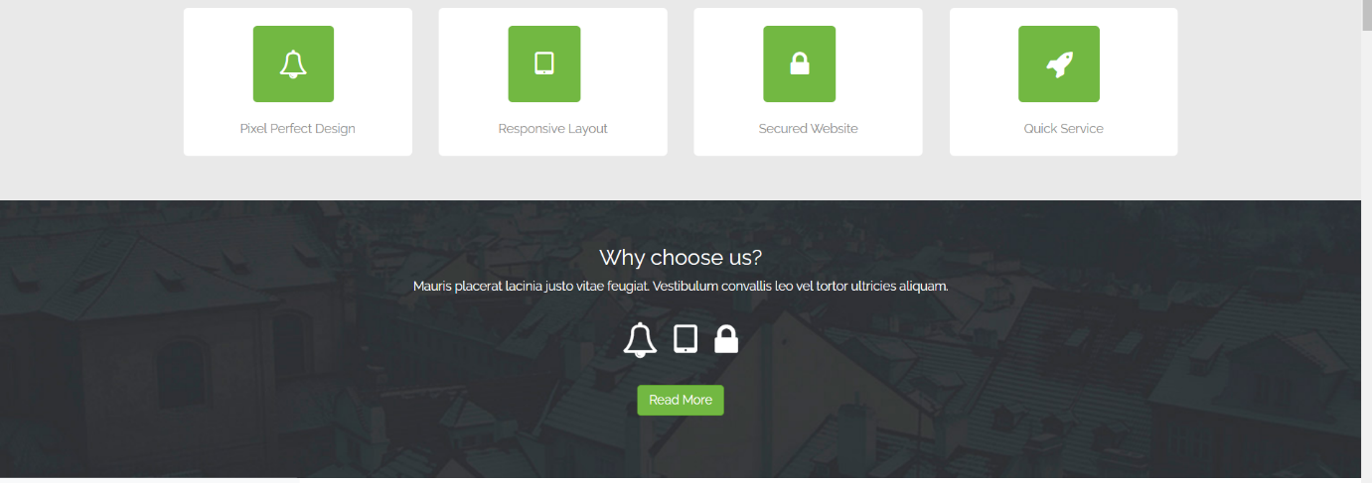

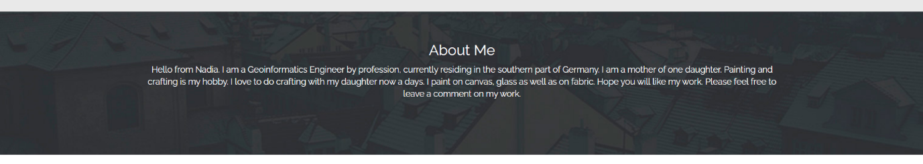

**Portfolio to Paintings**

* I renamed the menu name from portfolio to paintings and in this part, most of the changes are made.
* In the template, eight images were there under the menu head. I have twenty-four images, divided under two sub-heads. Twelve images under one sub-head. Eight of them are displayed and four are hidden. If we click on ‘view more’, the hidden four images will appear. There was a ‘view more’ button in the template but it was not activated. That’s why new functions ‘showHideGlassImage’ and ‘showHideAcrylicImage’ are added to activate the ‘view more’ button for Glass paintings and Acrylic paintings subhead respectively.
* And of course the images are replaced by my work. Image titles are changed accordingly.
* Hover is added in the portfolio thumb class for image hovering. Also a lighter and transparent background color is choosen for hover so that, we can see the image while hovering.
* Shadow and border radius is added to portfolio items to style the images.
* Margins and padding is added for styling.



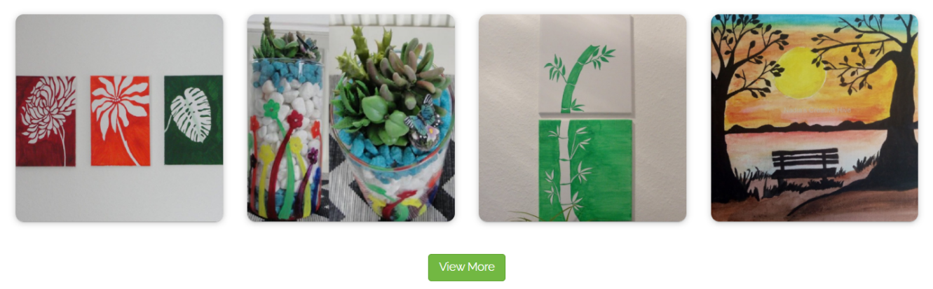

**Blog**

This menu is completely removed from my page.

**Contact**

* Text is replaced
* Location of Google map changed to my current location
* In the footer, four sections were in the template but I kept only one section (contact) and aligned it to centre for the large screen view (>768px). Code is shown in a previous section.

